Lab-03 Tasks:  
1. Perform the above illustrated samba configuration with screenshots attached

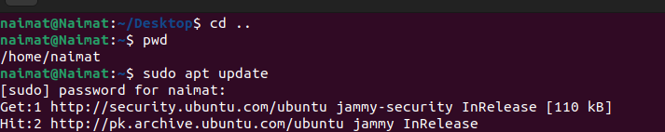

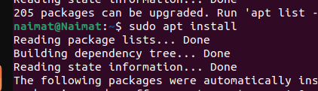

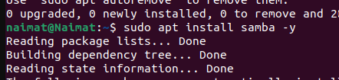

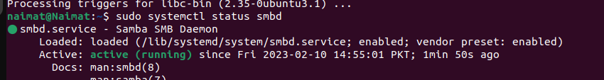

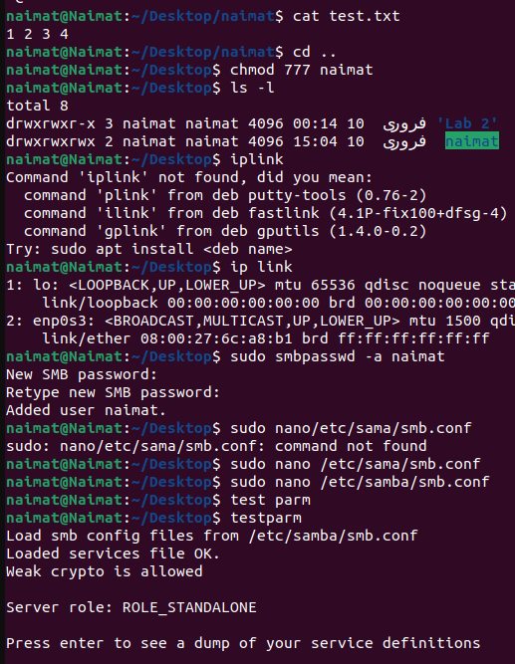

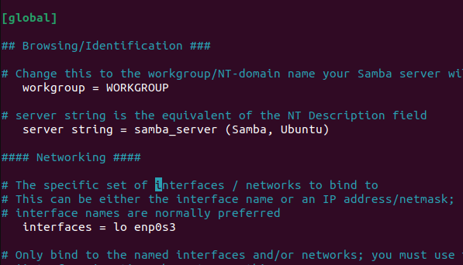



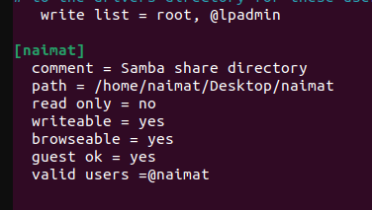

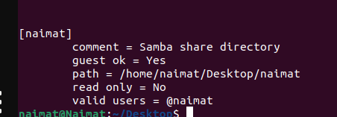

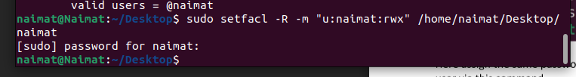

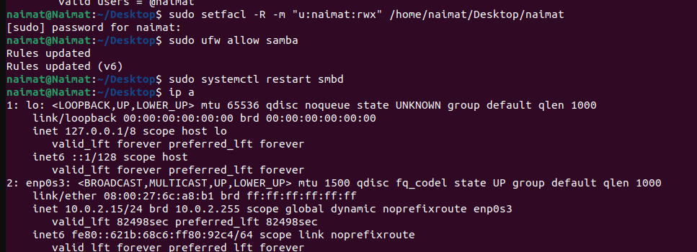

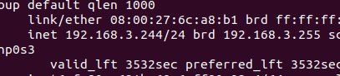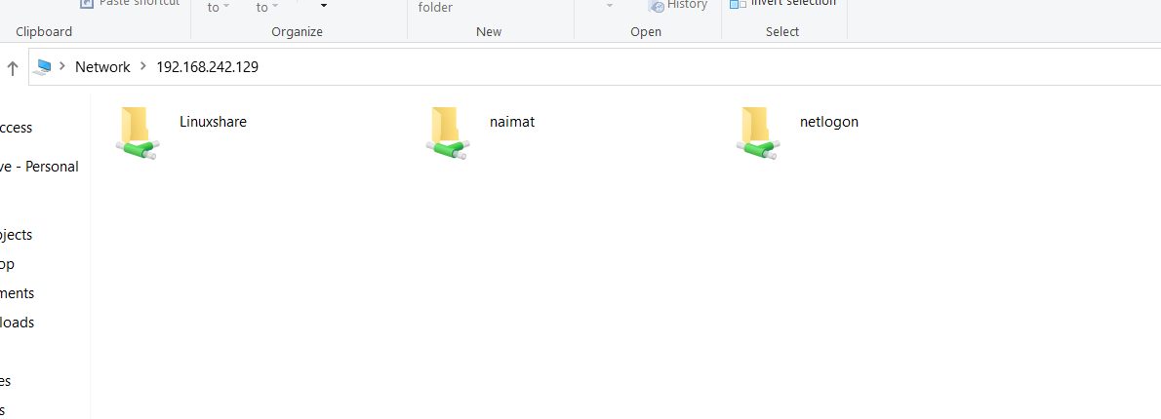

2. Write a C Program inside the Downloads folder of your windows directory via the ubuntu OS (either via the GUI text editor or nano) in which there exists two nested structures one OS_Class and other student with the properties OS_type as string, no of PC as int in OS_Class and in student rollno in string and semester enrolled in int and print them  
**Note: Compile the answer on ubuntu via the network share and should be present on the terminal**

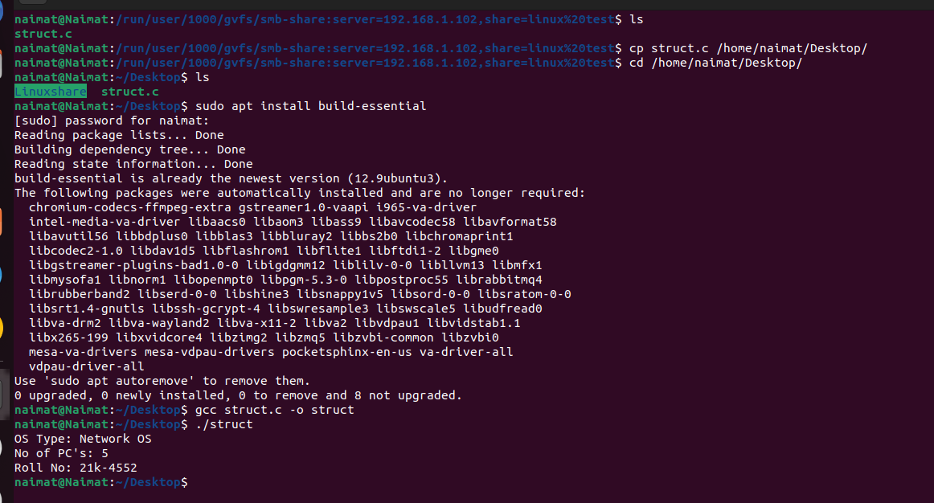

3. As the above stated question do the vice versa in this case use the share folder in ubuntu and access via windows on a software (either VSCode or Dev C++) and compile the answer on windows

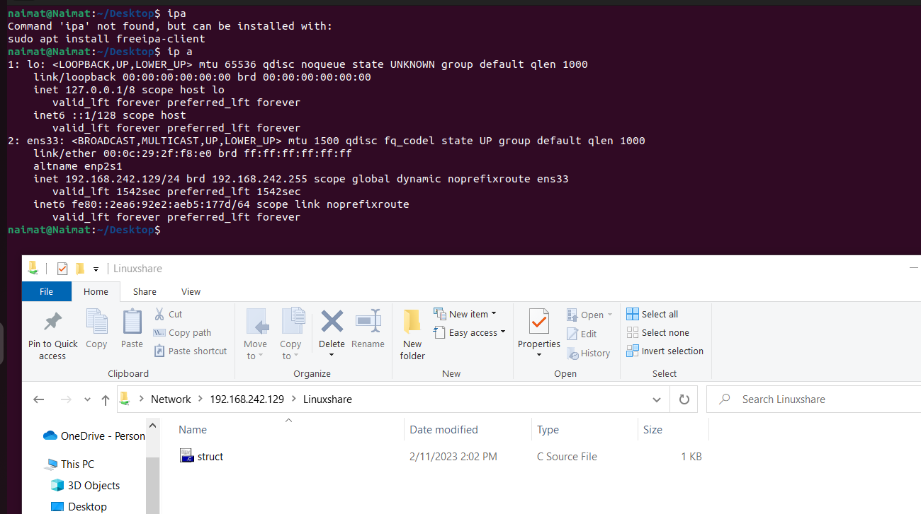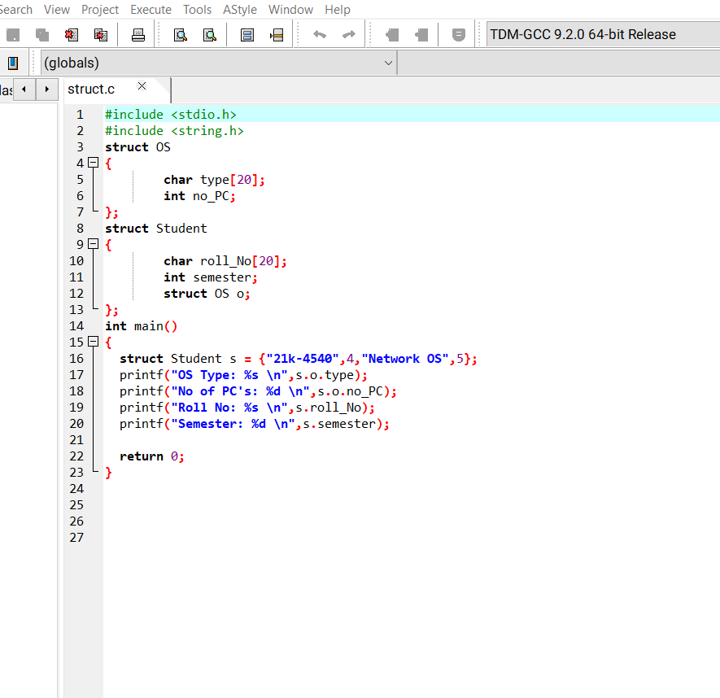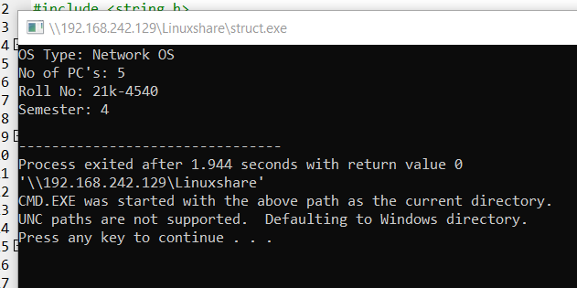

4.Write a script that locates and returns all files in the windows Desktop folder with the extension .C on Ubuntu

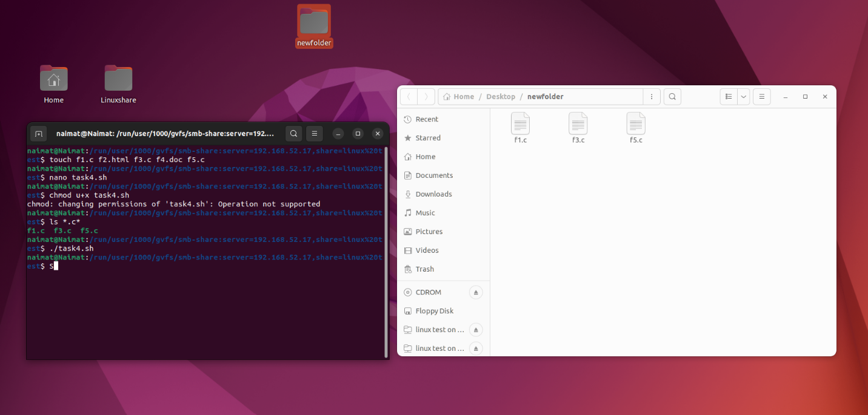

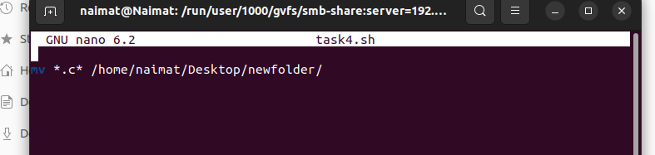

5.Write a script that reads a script on the windows folder share (can be any folder you assigned) and executes the script. Then asks for a file name to be created and move the file from the windows share to your ubuntu share (**note the mv command must be in the ubuntu script the windows script should only have either the touch command or cat command**)